1. Power CUSP via microUSB (or USB-C if using a RPi 4).
2. Once Cusp is powered, a wireless ad hoc network will be generated called “CUSP-XXX” where XXX will denote the unit number.
3. A user can then connect to this network just like any WiFi network using the password which is given upon arrival.
4. Upon connection, the user can now access the web app.

**Web App**

Go to the address 192.168.4.1:500 in a web browser.

This should bring you to the Home Page.

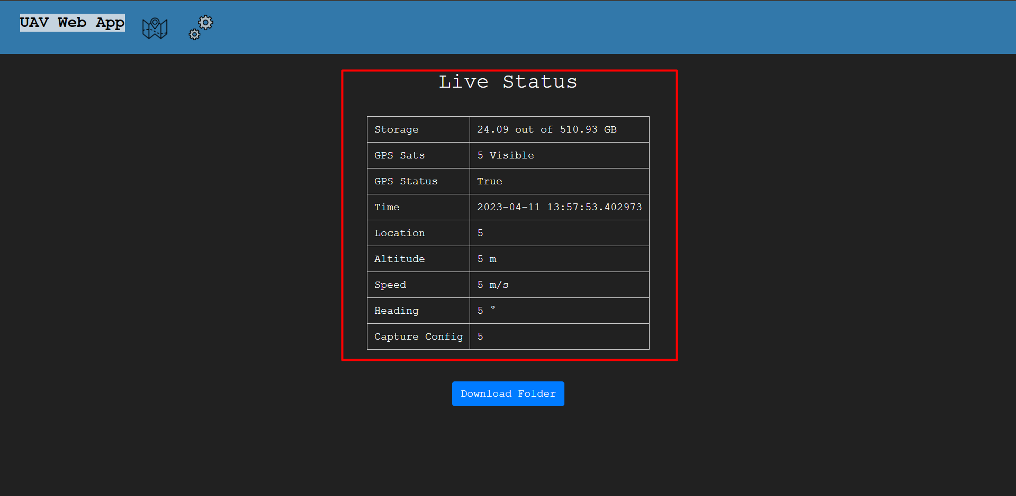

This part of the home page displays the status of the gps in real time.

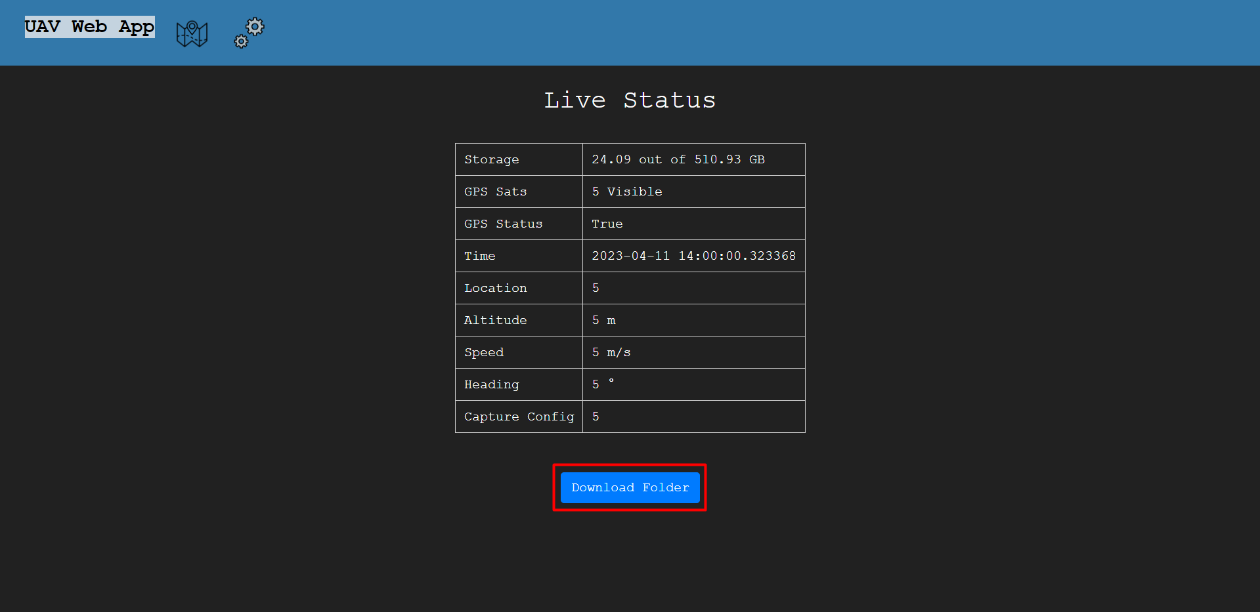

This button allows you to download a zipped folder of the images taken.

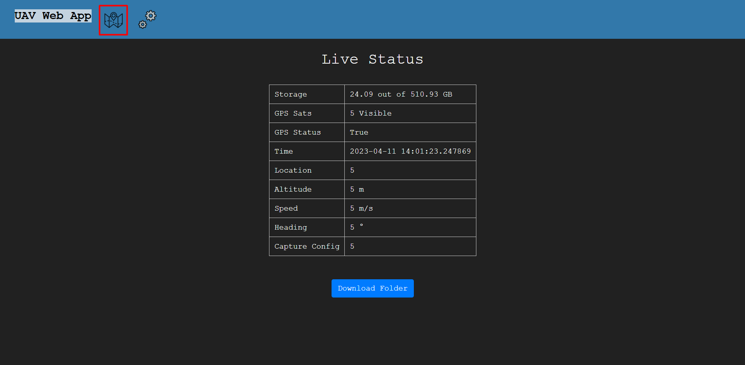

There are 3 tabs in the navigation bar at the top of the screen. This one will bring you to the Flight Estimator page.

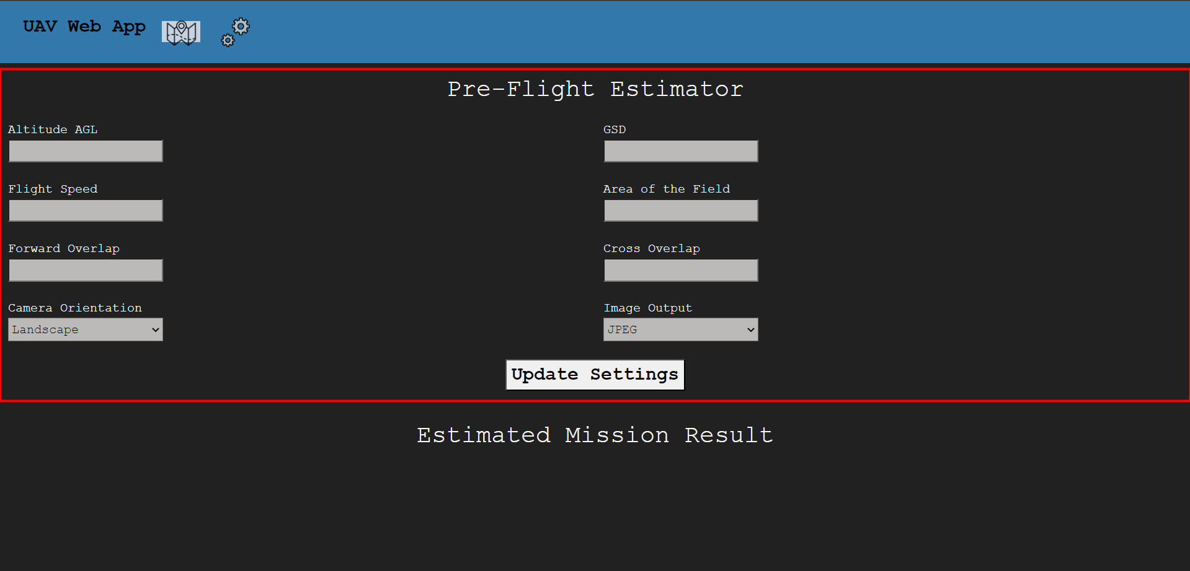

This section of the Flight Estimator page is where you input the values.

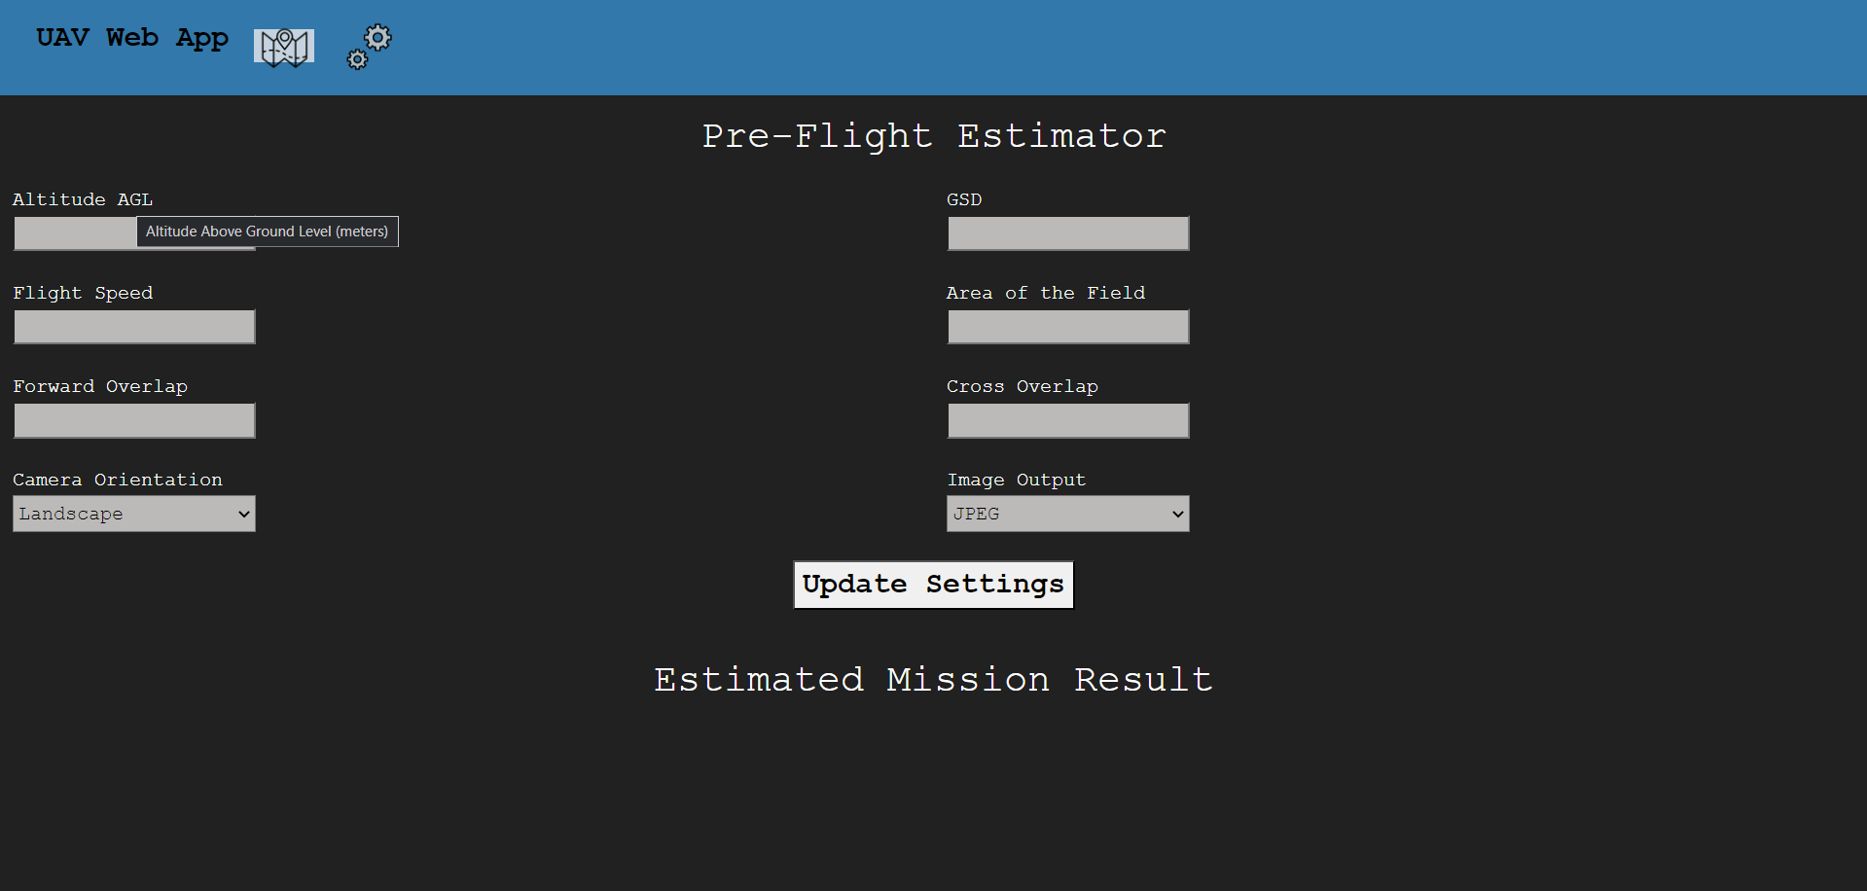

Hovering over any of the values will give you a description of what to input.

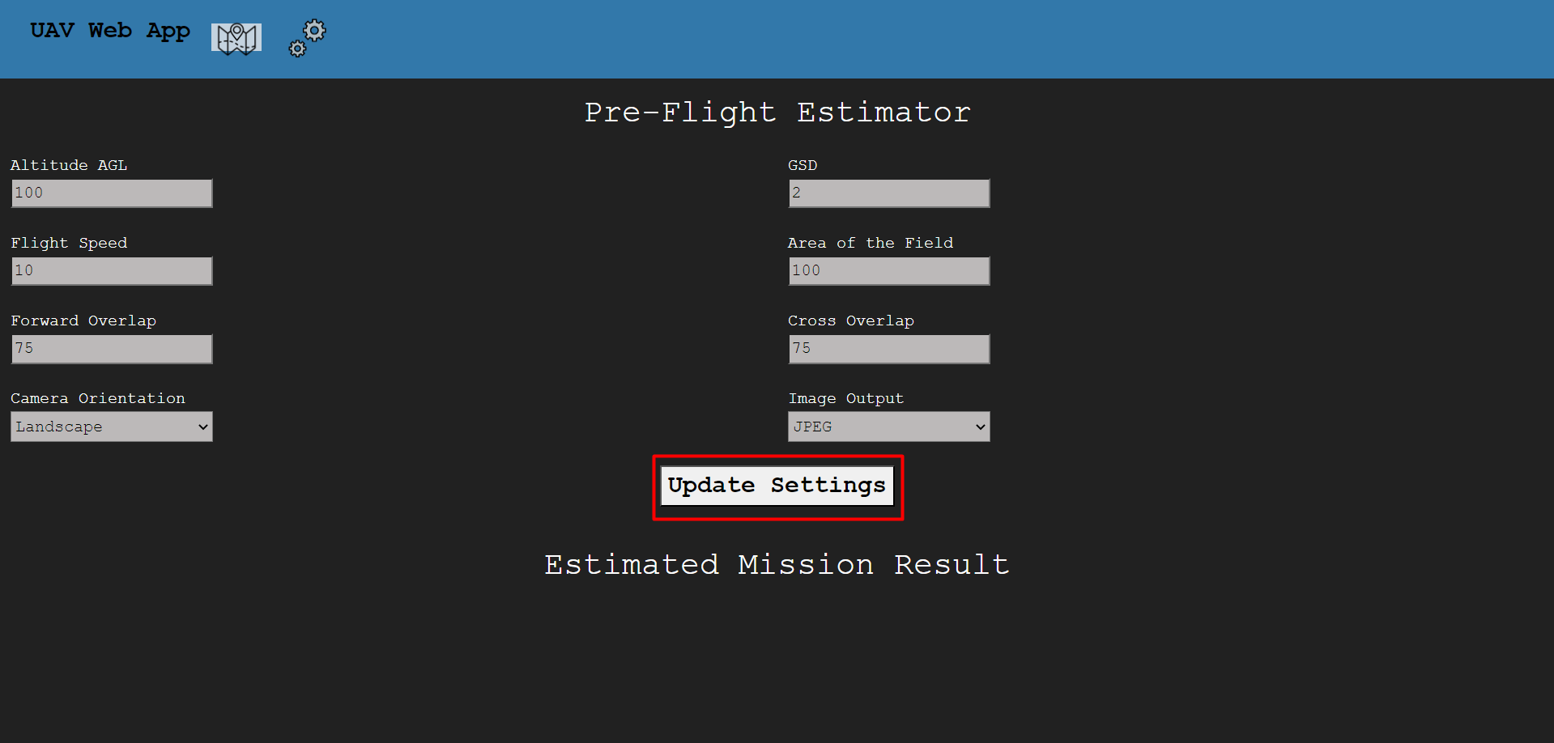

After entering your chosen values this button will perform the calculations.

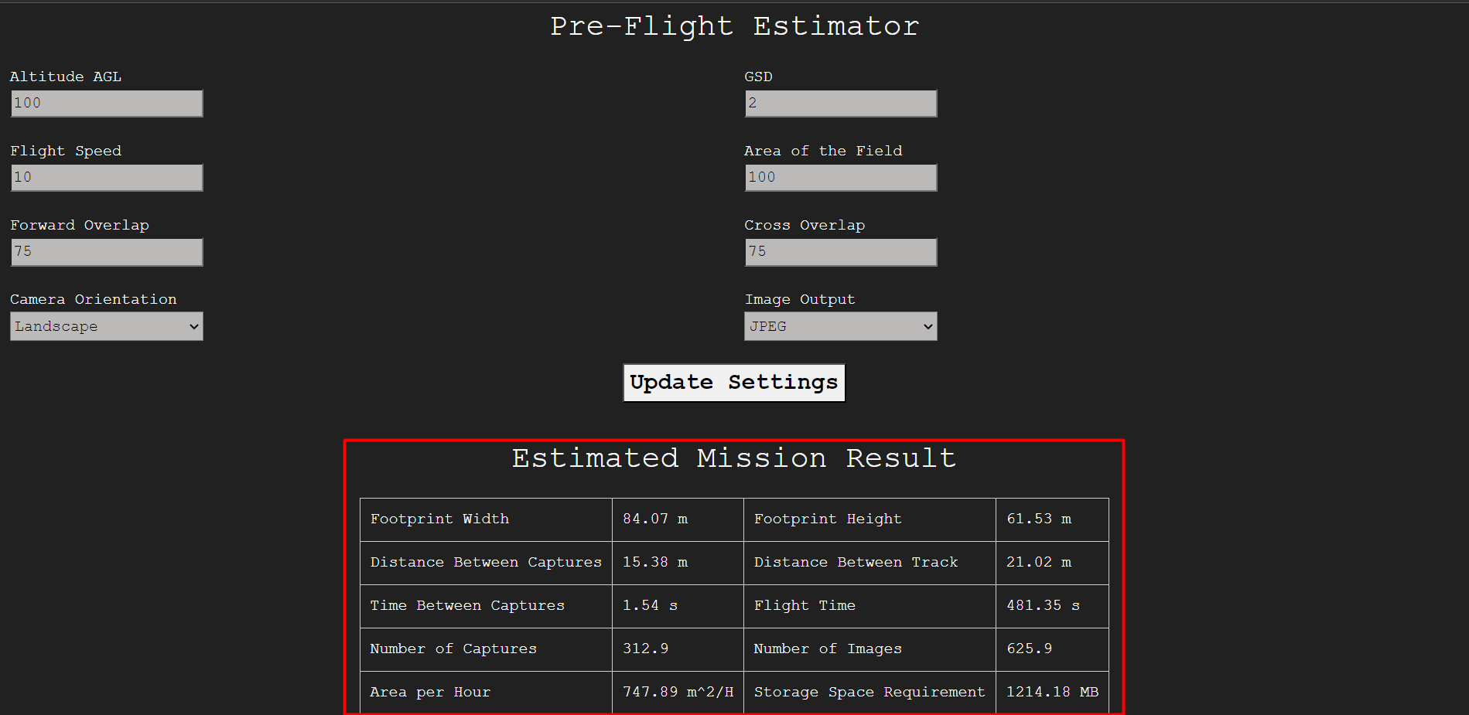

After clicking the button, the estimated mission result is shown here.

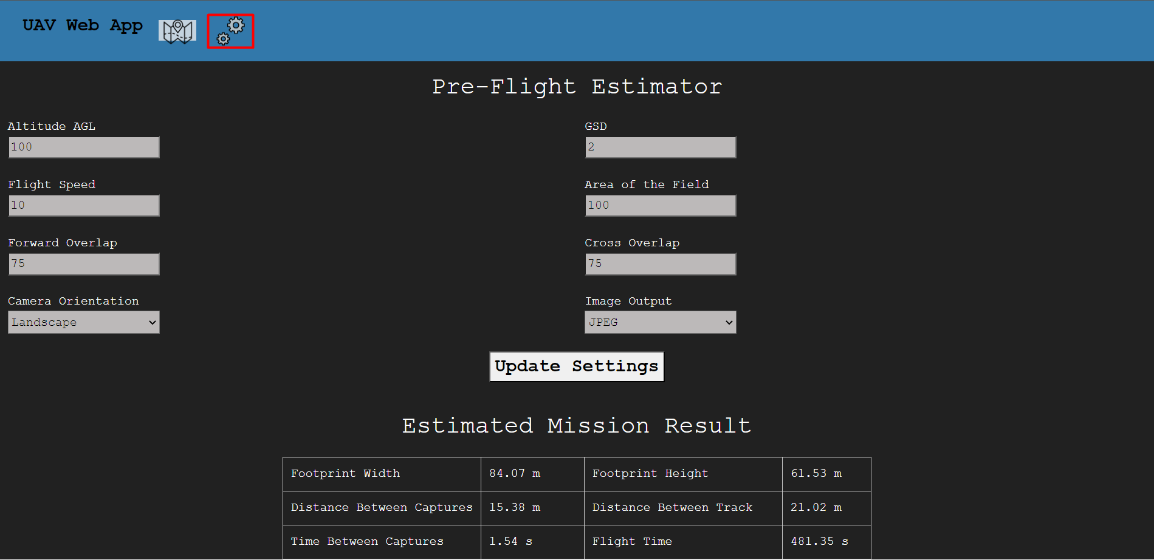

Heading back up to the navigation bar, this tab will bring you to the configuration page.

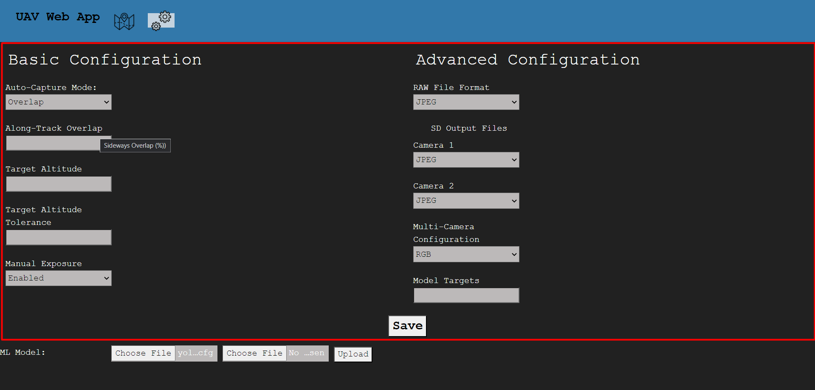

This is the configuration section. This also has the hovering ability to show a description of what the setting means. Model Targets does not have to be filled out to submit a configuration change.

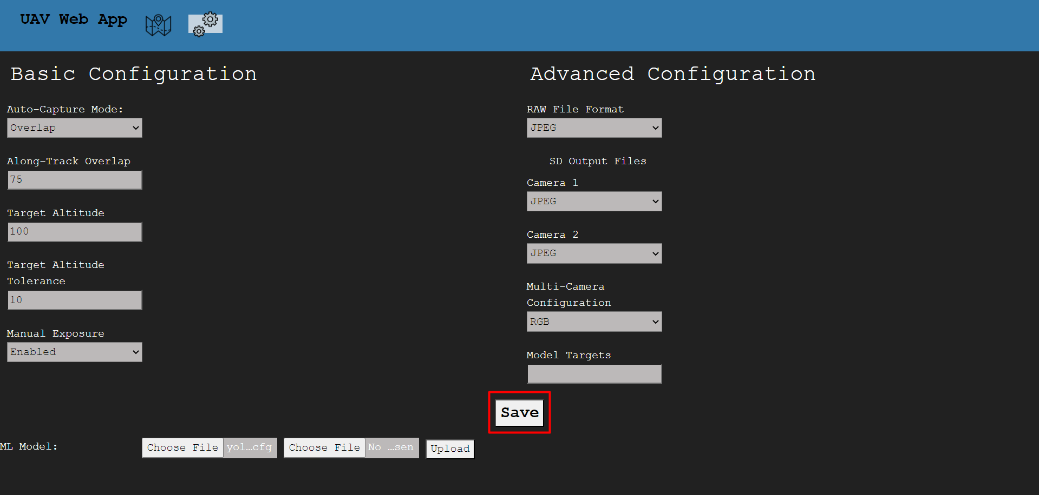Upon entering desired configuration settings, this button will upload those settings.

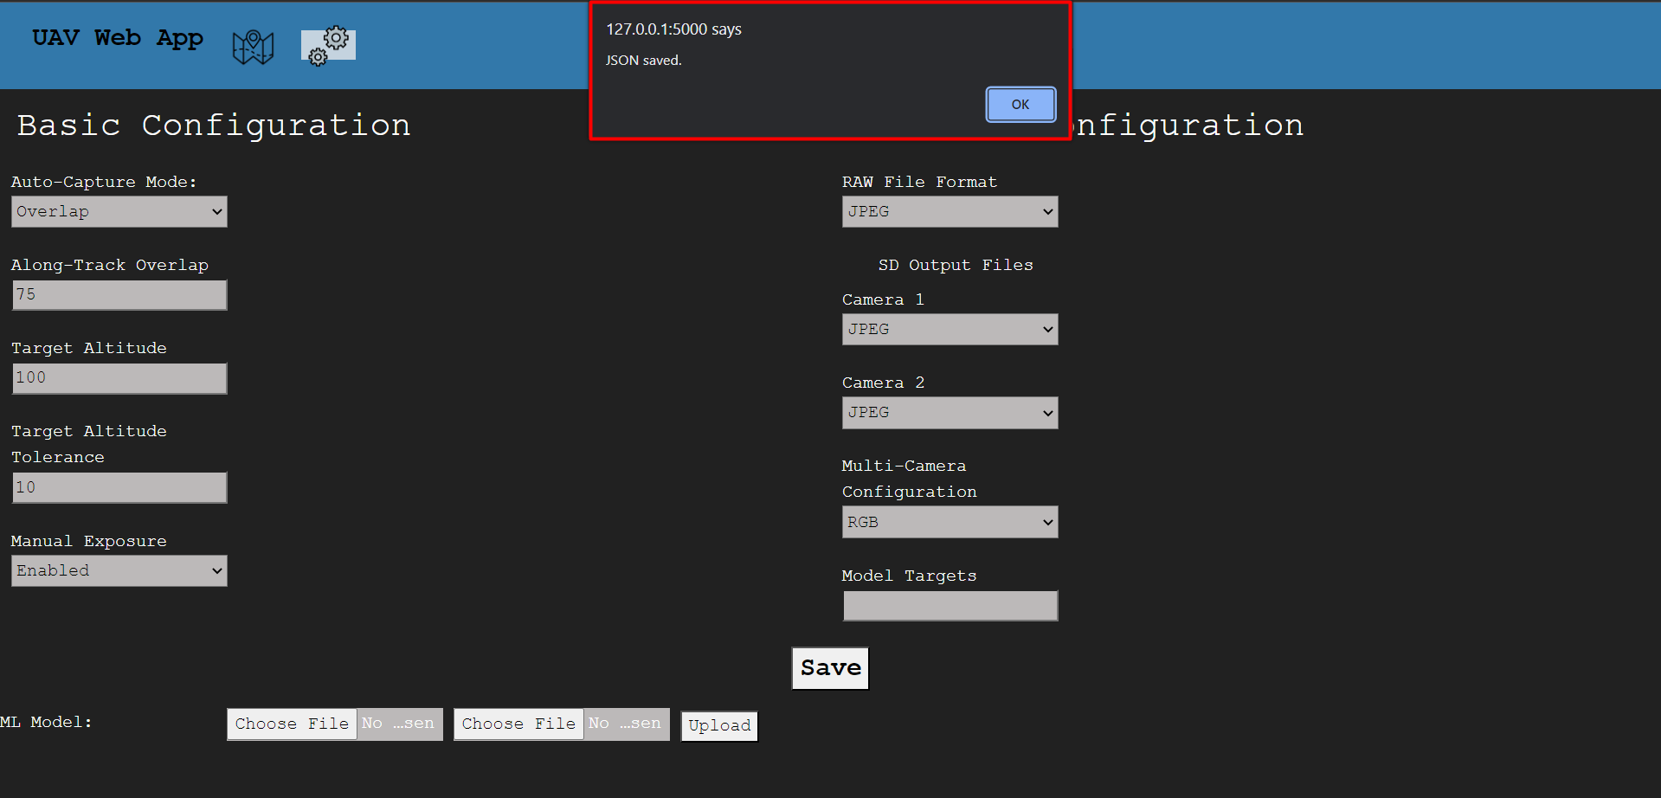

If successful, this message will pop up.

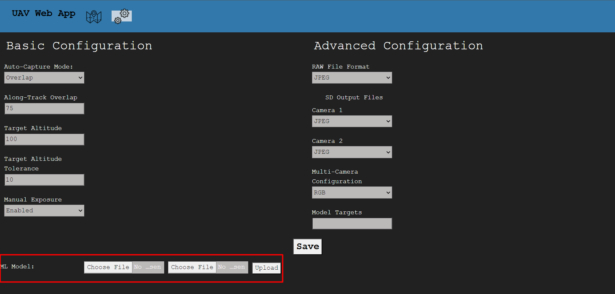

This section allows for the uploading of updated or new machine learning models.

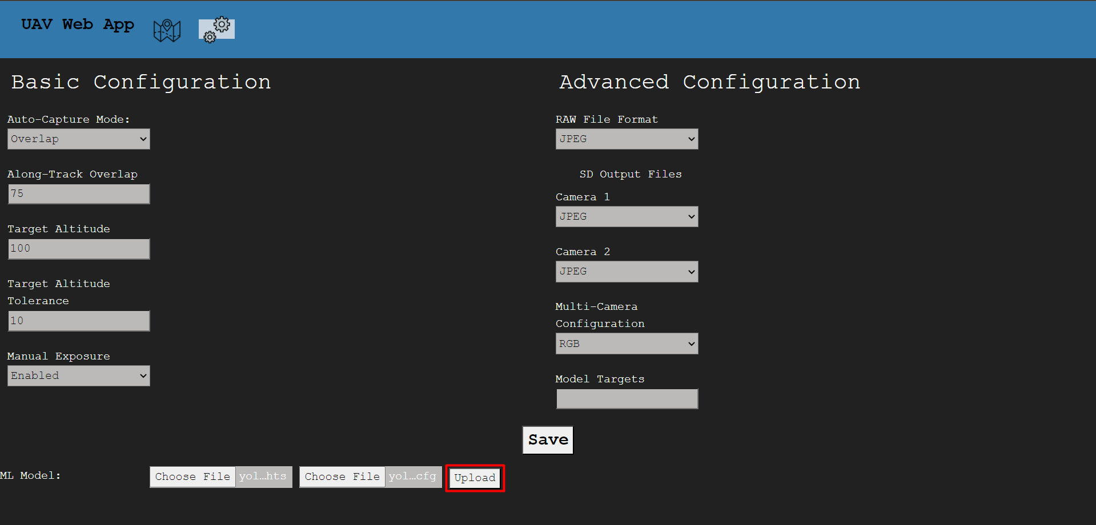

After choosing the .cfg and the .weights file, this button will upload the models.

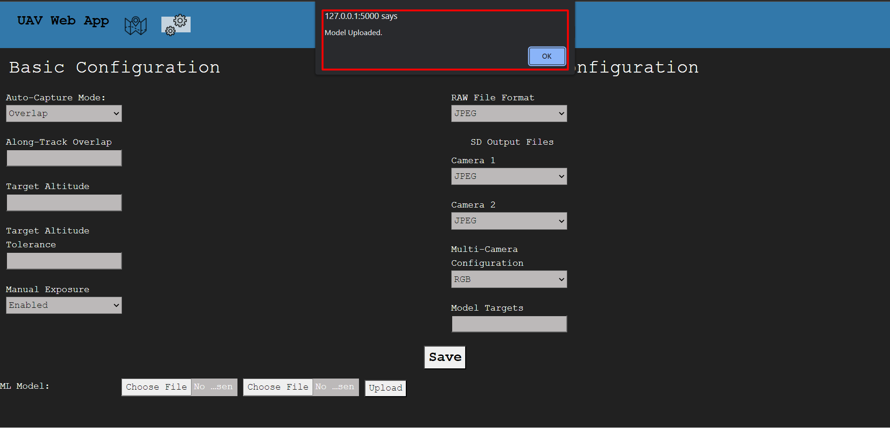Upon successful upload, this message will pop up.

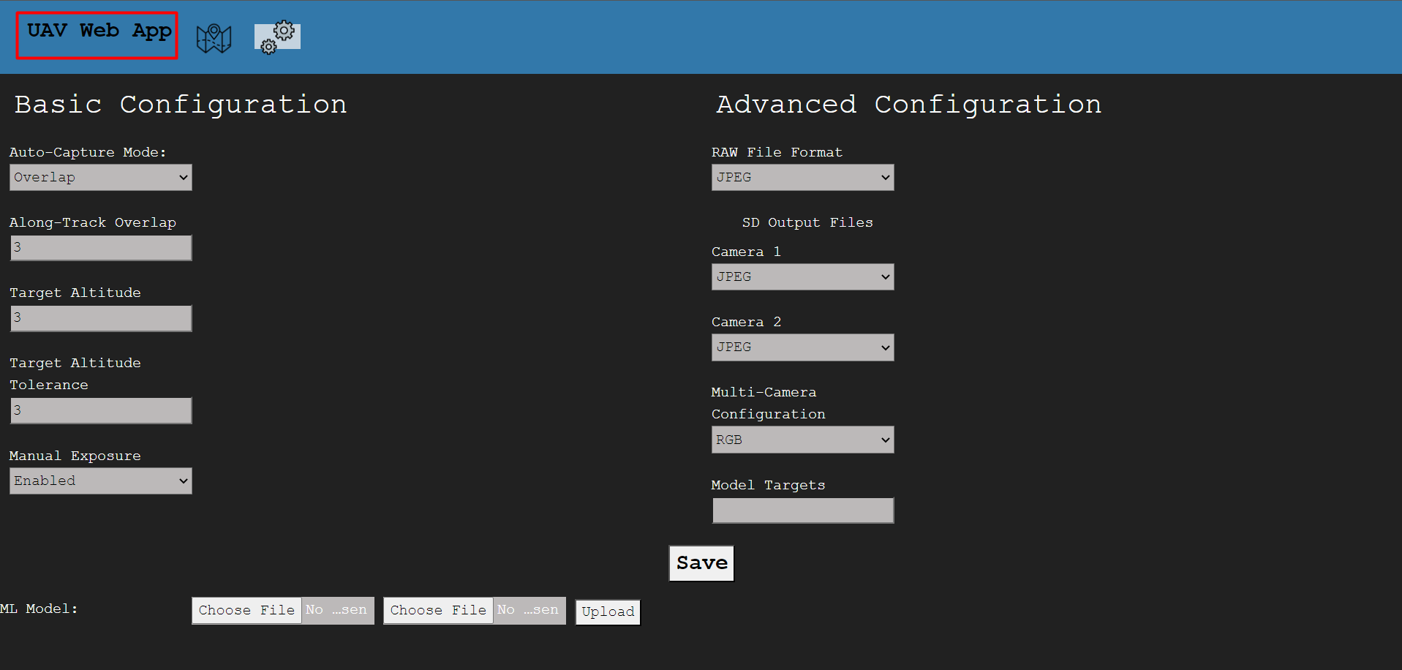

Lastly, this tab in the navigation bar will bring you to the home page.